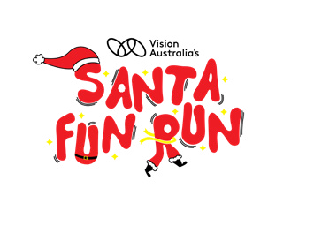

Vision Australia’s Santa Fun Run event guide

Vision Australia’s Santa Fun Run event guide

Vision Australia’s Santa Fun Run event guide

Vision Australia’s Santa Fun Run event guide

Table of Contents
Registrations 3
The more the merrier! 3
Race bibs 3
Upgrade ticket holders 4
Purchase and collection of event merchandise 5
Early bird reward winners 5
Wave start times 5
Event timetable 6
Event information 7
Getting there 7
Car 7
Bike 8
Public transport 8
Train 8
Tram 8
Bus 8
Bag drop 8
First aid 9
Course information 9
Start line 9
Course map 9
Drink stations 10
Toilets 10
Achievements 10
Fundraising 10
Get rewarded with your fundraising! 12
Raffle prizes up for grabs: 13
Event village 15
Site map 17
Share the magic of Carols by Candlelight 17
Thank you for your incredible generosity! 17
Our partners 18
Major partner 18
Event activation partners 18
Rewards partners 19

We’re so excited to welcome you to the third annual Vision Australia Santa Fun Run on Saturday November 22, 2025!
Thanks to our wonderful major event partner, Kay & Burton Foundation, this festive day is set to be unforgettable. We can’t wait to paint the town red with you as we fill the Tan Track with Santa spirit.
Thank you for being part of this incredible journey and for your amazing support!

Registrations

The more the merrier!
It’s not too late for friends and family to join you on this jolly jaunt! Online registrations will remain open until 11pm on Friday November 21, 2025.

To buy tickets at the door, last-minute registration can be made in person at the event between 8am – 9am and will close 30mins before the race is due to start at 9.30am. Please head to the race pack collection marquee for in-person registration to complete a manual entry form and payment. You will then be given a race bib to attach to your festive clothing.

Race bibs
This year, as part of your Santa Fun Run ticket, you will have received your race bib in the mail prior to the event. If you have not received your Race bib by mid-November, please email events.fundraising@visionaustralia.org before event day.

Anyone who has purchased a ticket after 11:59pm on Monday 27 October 2026, will have to collect your race bib at the race pack collection marquee between 8am – 9am.

Please complete your emergency contact details on the back of your race bib and attach it to your Santa Fun Run t-shirt or over your festive outfit. You do not need to register on-site, simply report to the start line at your chosen wave time.

Upgrade ticket holders
If you purchased a ticket upgrade during registration, please collect your upgrade card at the race pack collection marquee between 8am – 9am.

Please show your receipt of entry to staff to collect your upgrade card and then head to each designated marquee to collect:
- 1 x Santa Fun Run T-shirt
- 1 x Santa Fun Run merchandise item (hat or socks), supported by Kay & Burton Foundation
- 1 x Raffle ticket for the event day hamper draw (you have automatically been entered)
- 1 x Sausage in bread at the sausage sizzle
- Priority access to pre-race activations in the event village including face painting
Please note that t-shirts are available while stocks last and preferred sizing is not guaranteed. All merchandise items are available on a first come, first served basis so don’t forget to head over early! If you purchased a Santa Fun Run t-shirt but the size you selected does not fit, you can exchange this (if unworn) between 8am – 9am at the
t-shirt collection marquee. Sizes available depend on stock levels.

Upgrade tickets are only available with ticket purchase online before November 21, 2025, and cannot be upgraded at the event.

Purchase and collection of event merchandise
To add some extra festive flair to your outfit, you can purchase official Santa Fun Run merchandise at our online shop, for collection on the day. This includes the Santa t-shirts and our brand-new bucket hat and sock options.

All proceeds support Vision Australia’s specialist programs for children who are blind or have low vision.

Early bird reward winners
If you were one of the first 100 to register, you will be notified by email that you have scored yourself a an 8oz ‘made by Fressko’ BINO reusable coffee cup in Chilli or Clover. Please bring your receipt of entry to collect your cup at the race pack collection marquee.

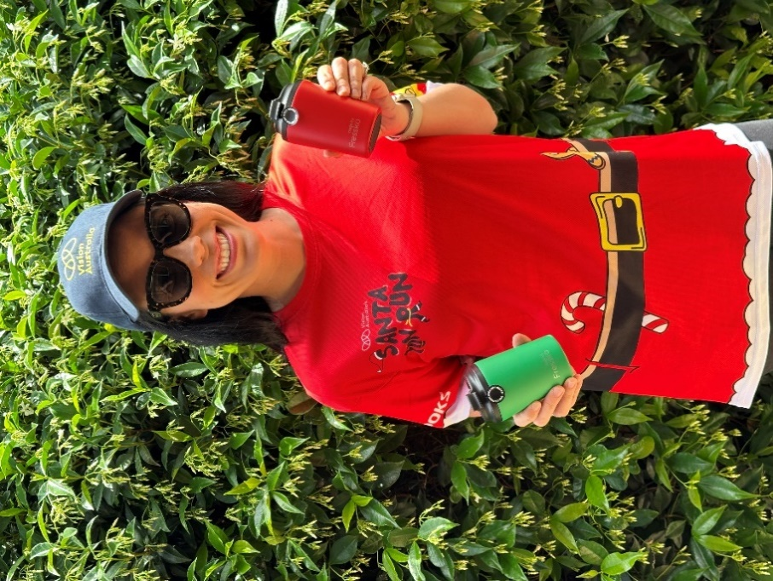

Wave start times
At registration, you will have selected from either Dasher (Wave 1) or Dancer (Wave 2). This determines your start time and distance as follows:
Dasher (Wave 1): 9:30am
2 laps, 7.6km for runners and fast walkers.
Dancer (Wave 2): 9:40am
1 lap, 3.6km for moderate and leisurely walkers

Please head to the starting line 10 minutes prior to your race start time.

Weather policy: The race will go on in the instance of wet or hot weather, however if local authorities issue an extreme heat warning, all waves will be reduced to one lap for health and safety reasons. You will be informed on the day if this is the case.

Event timetable

The Santa Fun Run Event Village will be open from 8am to 12pm with these activities scheduled at the following times:

Time | Activity
8am | Domain Coffee Cart and Lions Club sausage sizzle opens
8am - 9am | Registrations and race pack marquee opens
8am - 12pm | Bag drop available
8am - 12pm | Santa intermittently roaming with his merry elves for photos
8am-11am | Face painting available
9am | CEO to do Acknowledgement of Country and welcome / thanks
9:10am | Bonnie Anderson performing live
9:20am | Dasher Wave 1: Santa calls participants head to the start line
9:25am | Santa Says warm up at the starting line (first wave)
9:30am | Dasher Wave 1 starts (Wave 2 participants head to the start line)
9:35am | Santa Says warm up at the starting line (second wave)
9:40am | Dancer Wave 2 starts
10am - 12pm | Event Village activities open
10:45am | Thank you message from Vision Australia with last call for raffle tickets (10:55am)
11am | Bonnie Anderson to announce winners of raffle prizes drawn and presented to winners at 11am
11:15am | Bonnie Anderson performing live
12pm | Event concludes; Merry Christmas to all!

*Activity times may differ slightly on event day, please listen to event announcements on the day for further updates.

Event information

Getting there
The Kings Domain, Lawn 3 on Linlithgow Avenue, parallel to St Kilda Road (Opposite Tom’s Block). Proceed south on Swanston St continuing onto Princes Bridge / St Kilda Rd. Head to the opposite side of St Kilda Road (Queen Victoria Gardens Side). Continue walking south down St Kilda Road, turn left onto Linlithgow Avenue, then turn right onto Linlithgow Avenue on the southbound path. Continue down until you hit the path in front of the King George V Monument, then turn left.

The Tan is suitable for runners of all abilities on a gravel track except for a bitumen footpath along Anderson Street. The one tough part of running The Tan is 'Heart Break Hill' which is a 30m hill up Anderson Street, the rest being flat.

Car
There is ample parking within walking distance to the race Start and Finish areas (Located Kings Domain, Lawn 3).

Car parks are available along Alexandra Ave, Anderson St and Linlithgow Ave. Please read parking signs carefully.

Bike
We will provide bike parking at the event site. Please make sure to bring your own lock to ensure your bike is secure. Barriers can be used near the Bag Drop area.

Public transport

Train
The nearest train station to the event site is Flinders St Station and is just a short 10-minute walk to the event site. Please refer to Public Transport Victoria for route planning and the Saturday timetable.

Tram
Several tram services are available along St Kilda Rd. The closest stop to site is Stop 17 – Grant St – Police Memorial / St Kilda Rd. Please refer to Public Transport Victoria or TramTracker for further details including pram accessible tram stops and route planning.

Bus
Buses 216, 219 or 220 travel along St Kilda Road which will bring you closest to King’s Domain. Please refer to Public Transport Victoria for further details and to plan your route.

Bag drop
Free clothing storage is available during the event, please bring your own bag or backpack to store items in to minimise waste at the event as single-use bags will not be provided. Your Race Bib features a tear-off strip for you to attach to your clothing bag for identification. Please don’t leave any valuables at the bag drop, we cannot accept responsibility for any items that are lost or stolen.

First aid
St John’s First Aid bike response crews will be on course, in addition to the first aid station at the finish line at Kings Domain, Lawn 3.

Course information

Start line
All events start next to Kings Domain, Lawn 3 on the path in front of the King George V Monument.

Course map
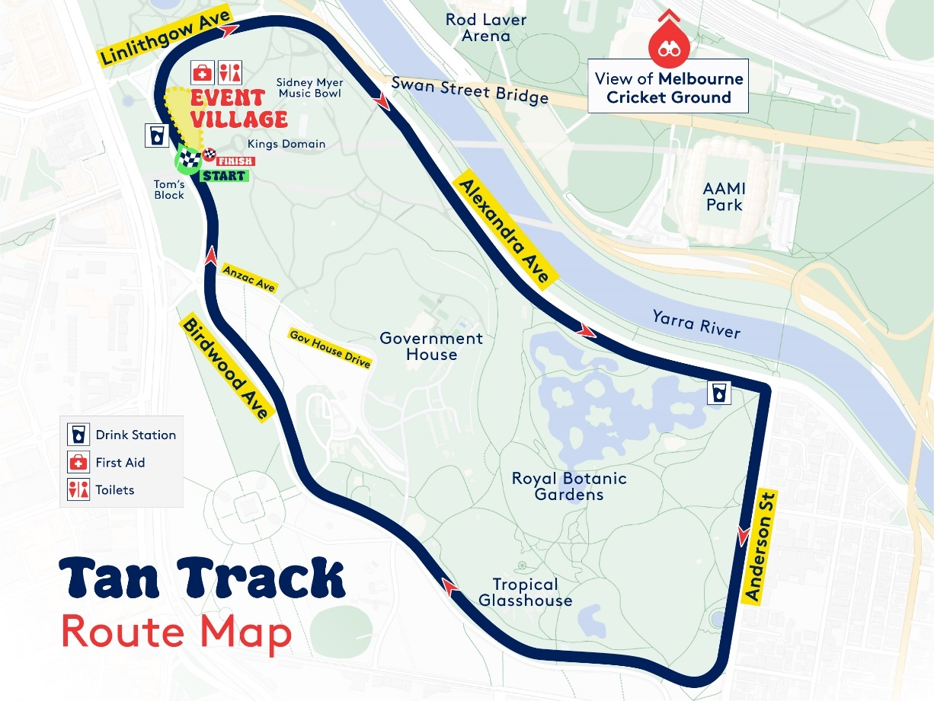
To view in Google Maps click here

Drink stations
Drink stations will be located approximately every 2km along the course. All participants will receive water at the finish line.

Toilets
Portable toilets and an accessible portable unit will be located at the Event Village. Note: There will be signs pointing you in this direction of these toilets.

Achievements
Please note that this race is not a timed event. Participants are welcome to time themselves on their own devices. Each participant will receive a certificate of participation which will be available to download after the event.
Certificates will be available to view at: https://fundraise.visionaustralia.org/santafunrun/results

Fundraising
This family-friendly event raises funds Vision Australia’s Life Ready Program. Life Ready supports the development and education of young people who are blind or have low vision. This gives kids a strong foundation for a lifetime of independence, helping them to discover and achieve their goals. It also ensures that families never feel alone, with support navigating life when their child has been diagnosed with a vision condition.
Your generous support of Santa Fun Run means that families can start receiving support and early intervention without delay, while connecting with others that are having the same experience.
Log into your Santa Fun Run fundraising dashboard to share your page.
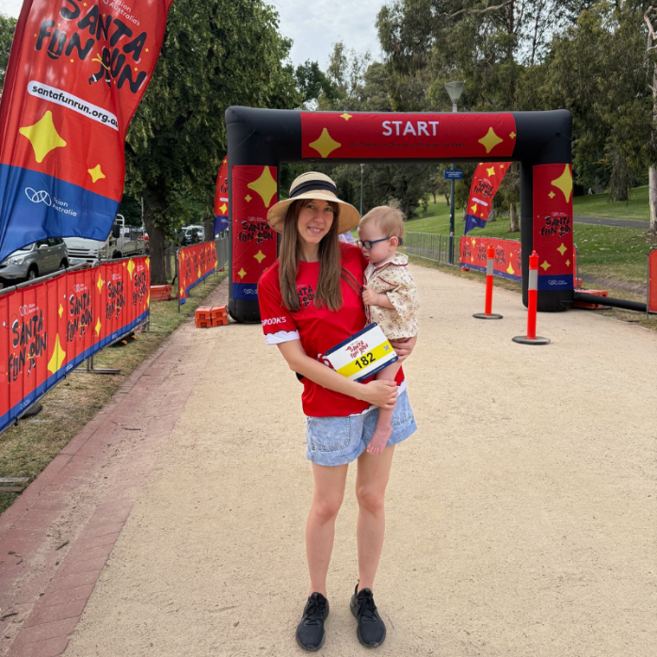
$30 Can give kids access to tactile books so they can enjoy story time too
$60 Can help provide kids with long white canes to help get to school safely
$100 Can help provide daily living sessions to learn the basics of self-care
$310 Can help set up the best assistive technology so students can thrive
Thank you for being part of Vision Australia’s Santa Fun Run. Your support helps to light up children’s lives this Christmas.
Donate now.
Find out more about the impact your fundraising efforts have made here.

Get rewarded with your fundraising!
To thank you for your amazing fundraising efforts we have a HUGE range of prizes up for grabs including:

- Individual rewards for fundraising milestones: The more you raise the more chance you have of winning a reward to thank you for your efforts from our incredible partners including gifts from Cherry Hill Orchards, made by Fressko, The Ascott Limited and Vision Australia’s own Carols by Candlelight.
- Team rewards for fundraising milestones: Teamwork makes the dream work! As you achieve your team fundraising milestones you will go into the draw to win a reward to thank you for your efforts from our incredible partners including gifts from Gumbuya World, Brooks, and Vision Australia’s own Carols by Candlelight.
Not to mention, this year we are so excited to provide all participants with a finisher reward! All registered Santa Fun Run participants will get a finishers gift bag full of goodies on event day, including a premium travel size gift from Salt Lab. Our youngest fun-runners will get their own goodie bag and choose from a special Barbie, Hot Wheels, Pokémon MEGA or Fisher Price gift thanks to Mattel.

That’s not the only haul Santa will be slinging. Be sure to head to the event village to grab a Brooks sweat band and snap up your raffle tickets here or at the RACE PACK COLLECTION marquee before 11am for your chance to score big in our event day raffle!

The raffle will be drawn at the event village by Santa at 11am. Don't miss the live draw, winners can claim your goodies on the spot

Raffle prizes up for grabs:
Raffle Hamper #1 valued at over $960
Item | Sponsored by
Sports themed Barbie (assorted) | Mattel
Pokémon MEGA (assorted) | Mattel
Hot Wheels Core Mattel 80th Anniversary 5-Pack | Mattel
Fisher-Price Purple Monkey Musical Storybook | Mattel
LEGO Technic (42114) | LEGO
LEGO Christmas (40499) | LEGO
1x Merry People Voucher to buy 1x adult and 1x children’s Bobbi boots | Merry People
2x sock advent calendars (1x women’s, 1x men’s) | Aussie Socks
Toy Library annual membership | Richmond Toy Library
Raffle Hamper #2 valued at over $630
Item | Sponsored by
Sports themed Barbie (assorted) | Mattel
Pokémon MEGA (assorted) | Mattel
Hot Wheels Core Mattel 80th Anniversary 5-Pack | Mattel
Fisher-Price Purple Monkey Musical Storybook | Mattel
LEGO Creator (31142) | LEGO
LEGO Christmas (40499) | LEGO
4x pairs of socks (1x Batman, 1x Make up, 1x starry hearts, 1x game socks) | MADMIA
2x sock advent calendars (1x women’s, 1x men’s) | Aussie Socks
Toy Library annual membership | Richmond Toy Library
Raffle Hamper #3 valued at over $550
Item | Sponsored by
Sports themed Barbie (assorted) | Mattel
Pokémon MEGA (assorted) | Mattel
Hot Wheels Core Mattel 80th Anniversary 5-Pack | Mattel
Fisher-Price Purple Monkey Musical Storybook | Mattel
LEGO City (60321) | LEGO
LEGO Christmas (40499) | LEGO
2x pairs of socks (1x Batman, 1x Make up) | MADMIA
2x BINO cups | Made by Fressko
Toy Library annual membership | Richmond Toy Library
Individual raffle prizes
Gift certificate for a family Portrait Photography Session and a 25x37cm Colour or Black & White Portrait, to the value of $2,000 | Artist Photographer
Gift certificate for a family Portrait Photography Session and a 17x25cm Colour or Black & White Portrait, to the value of $1,000 | Artist Photographer
Luxy MECCA hamper valued at $1,500 | MECCA
LEGO Duplo (10932) | LEGO
LEGO Friends (42630) | LEGO
2 winners to receive 2x pairs of socks (Assorted) | MADMIA
5x winners to win 1x women’s sock advent calendar | Aussie Socks
5x winners to win 1x men’s soc advent calendar | Aussie Socks
Check out all the rewards, prizes and T&C’s here.

Event village

There will be something for everyone at the Event Village including these fun activities:
Kay & Burton Relaxation Station
Join Key & Burton Foundation at the finish line at the relaxation zone. Put your feet up, take a well-deserved rest and enjoy a coffee from the DOMAIN cart.
Puppy Chill Out Zone
Supported by Zoetis and Royal Cannin, here’s your chance to meet and pat our adorable Seeing Eye Dog puppies in the fur!
Kids’ activity zone
Our youngest fun-runners can enjoy some great sensory activities and face painting, hosted by our wonderful Vision Australia Children’s Services team.
Write a Braille letter to Santa
Enjoy the inclusive tactile event village signage and even write a letter to Santa using our Brialle machines, supported by Braille Tactile Signs Australia.
Santa selfie-stop
Take a selfie with the one and only Santa and his merry elves, sit on Santas throne or enjoy the background of festive props.
Live music and entertainment hosted by Bonnie Anderson
Groove to live festive tunes provided by our amazing MC, Bonnie Anderson as well as the St Jospeh’s College and Chairo Christian School bands.
Lions BBQ
Refuel and refresh with a CAPI drink and bite to eat at the Lions BBQ (vegan and gluten free options available).
Brooks van
Run on over to the Brooks Van and find your perfect Brooks fit. Check out the latest Brooks footwear PLUS the chance to WIN a pair of Brooks shoes!
Try your hand at Goalball
Learn how to play goalball, a fun adaptive sport that was originally designed for people who are blind or low vision. It’s a fun and accessible game that can be enjoyed by everyone, supported by Victorian Goalball Association.
Melbourne Victory
Come and become a mini Roo and test your soccer skills with Melbourne Victory! Take aim and kick the ball through the mini soccer encloser. Super fun for ages 3+.
Nova
Join the Supernova team for some family fun games and great entertainment.
Vision Store
Check out the Vision Store marque to find out more about reading technology, leisure and recreation activities and assistive communication tools.
Giant lawn games
Play a game of giant Jenga or Connect Four with these larger-than- life lawn versions.

Site map

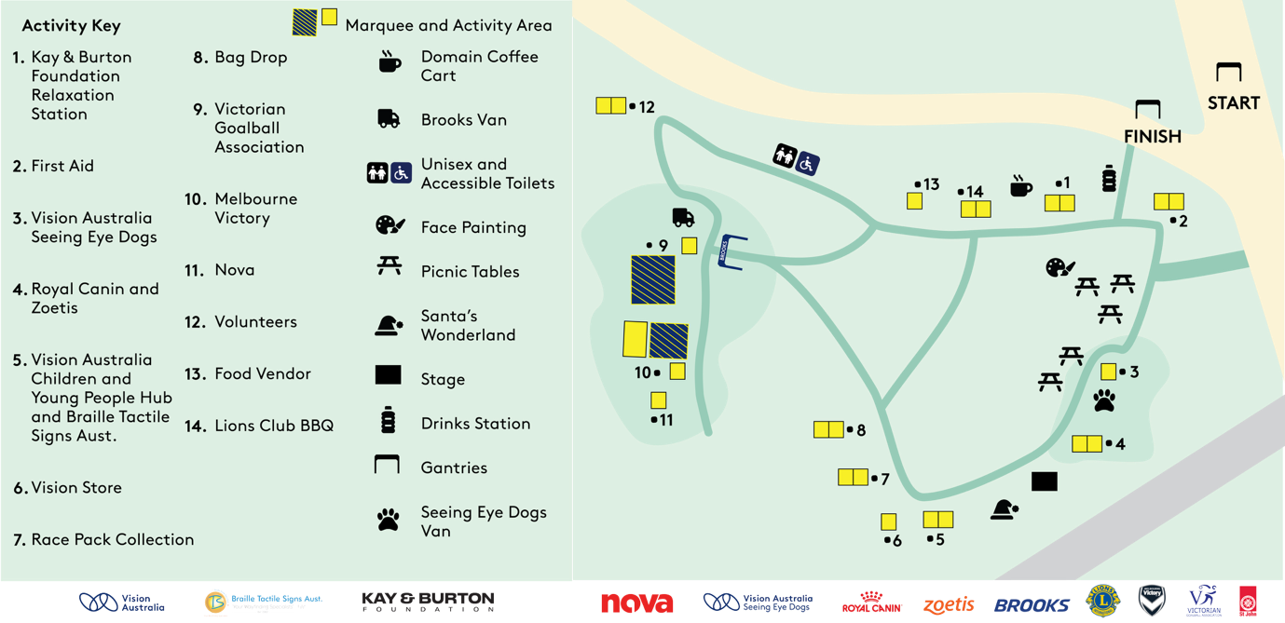

Share the magic of Carols by Candlelight
Continue the spirit of the season this Christmas Eve as Melbourne’s Sidney Myer Music Bowl transforms into a place of music, magic and wonder for Vision Australia’s Carols by Candlelight, presented by AAMI.

Ticket sales and donations from Carols by Candlelight fund the education and development of children and teens who are blind or have low vision, helping them form strong foundations for a lifetime of independence and meaningful inclusion. It also ensures that families never feel alone, with support navigating life when their child has been diagnosed with a vision condition.

It’s an event not to be missed! Experience the magic in person by buying tickets at https://carols.visionaustralia.org/tickets or tune into Channel 9 for the live broadcast.

Thank you for your incredible generosity!
We wanted to take a moment to express our deepest gratitude to our partners for making this event possible and to you, for your generous support of Vision Australia’s Santa Fun Run and the community we support.

Your kindness and participation in the Santa Fun Run have helped to raise important funds for Vision Australia’s Life Ready program to make this Christmas brighter for children who are blind or have low vision.

Our partners
We are proud to work with fantastic partners. Their support makes it possible to deliver this event and raise funds for Vision Australia’s specialist children’s services
Major partners:


Event activation partners



Rewards partners

